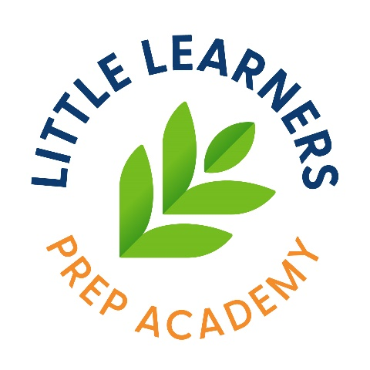
NON-DAIRY/ MILK ALTERNATIVE PERMISSION FORM

As the parent/guardian of ___________________________________________, my preference is that he/she consumes the following substitute for whole and/or 1% cow’s milk. I understand that I must provide the milk alternative to Little Learner Prep Academy for my child to consume while in their care.

I am providing______________________________________________ (*name of alternative i.e.: lactose-free milk, oat milk, soy milk, etc.…) as an alternative for whole and/or 1% cow’s milk.

*As Little Learners is a nut-free facility, we will not accept nut-derived milk substitutes.

Parent Signature: ____________________________________________________________
Date: ___________________________________

